ERGONOMIC EXERCISE DECREASES BLOOD PRESSURE, PULSE AND STRESS LEVEL IN PRIMARY HYPERTENSION PATIENTS AT SOKOBANAH SUB-DISTRICT, SAMPANG DISTRICT MADURA
Holilah^{1(CA)}, Erma Sulistyaningsih², Hadi Prayitno³
^{1 (CA)} Undergraduate Public Health Program, University of Jember, Indonesia; holilahlila200@yahoo.com (Corresponding Author)
² Faculty of Medicine, University of Jember, Indonesia;sulistyaningsih.fk@unej.ac.id
³ Faculty of Social and Political Sciences, University of Jember, Indonesia; hprayitno29@yahoo.co.id
Submitted: October 3, 2018 -Revised: November 1, 2019 -Accepted: December 1, 2019 -Published: January 31, 2019

ABSTRACT

Hypertension is a condition in which the blood pressure elevated above 140/90 mmHg. Stress is one of the factors that cause hypertension. In this case, one of the alternatives to improve the hypertensive patients’ physical condition of blood flow and nerves is ergonomic exercise. Thisstudy purposed to analyze differences in blood pressure, pulse, and stress level through ergonomic exercise in patients withprimary hypertension at Sokobanah sub-district, Madura Regency. This research used quantitative research method with pre-experimental one group pretest-posttest. The population was 55 patients. In consequent, 48 people were taken as sample by simple random sampling. Data analysis with Wilcoxon signed rank test was conducted for the analysis and it showed differences on blood pressure (p-value: 0,000), pulse (p-value: 0,000) and stress level (p-value: 0,000) in primaryhypertensive patients before and after being given ergonomic exercises at Sokobanah Subdistrict, Sampang Madura Regency.

Keywords: Ergonomic Exercise, Blood Pressure, Pulse, Stress Level, Hypertension

INTRODUCTION

Hypertension is a condition in which the blood pressure elevated above 140/90 mmHg and a main cause of stroke, heart disease, kidney and peripheral circulation problems ⁽⁴⁾. Hypertension is also categorized as a silent disease or a silent killer because sufferers would not know if the patient has hypertension before checking the blood pressure. Additionally, the worst impact of hypertension is death. Prevalence of hypertensionis associated with several major factors and minor factors. Major factors are heredity, gender, race and age, while minor factors include food (salt consumption), alcohol, stress, obesity and smoking ⁽⁵⁾. In addition, hypertension is also influenced by exercise habit. In this case, a person who does not do physical exercise enough, he will decrease the blood flow.
Patient with hypertension must get proper and safe treatment, regarding pharmacologically and non-pharmacologically treatment^{(6).} Pharmacological treatment is the same to consuming drugs, namely diuretics, adrenergic inhibitors, ACE-inhibitors, ARB ⁽⁷⁾, vasodilators. Meanwhile, non-pharmacology can be in the form of exercise, such as ergonomic exercise. Ergonomic gymnastics is good for the health of the human body. This movement can open, clean, and activate systems in the body, including cardiovascular, urinary and reproduction. Physical exercisealso can relax blood vessels; eventually ergonomic exercise will relax blood vessels, so that blood pressure will decrease ⁽⁵⁾.
The location of Sokobanah Sub-district is very close to the beach and the citizens still consider hypertension as a common disease that has no serious effect. This situation might happen due to the lack of awareness and knowledge about the risk of hypertension. Hypertension or high blood pressure is actually suffered by most of Madurese. Genetic or hereditary factors are the highest cause, besides the high salt content in most of their food; it becomes a trigger for the prevalence of this silent killer disease in Indonesia. As we know, the Madurese have a very temperamental character, so their blood can be easily elevated and this condition may lead to be a trigger for hypertension.

Goal

This study purposed to analyze differences in blood pressure, pulse, and stress level before and after doing ergonomic exercise in patients with primary hypertension at Sokobanah Sub-district, Sampang Madura Regency.

Hypothesis

There are differentces in blood pressure, pulse and stress levels before and after ergonomic exercises in patients with primary hypertension at Sokobanah Sub-district, Sampang Madura Regency.

METHODS

This quantitative research used a pre-experimental one group pretest-posttest research design. This research was carried out in Sokobanah Sub-district, Sampang Madura Regency. Sampling technique used was simple random sampling, from population of primary hypertension patient in Sokobanah Subdistrict, Sampang District, Madura Regency who met the inclusive criteria. The sample in this study was all patients of primaryhypertension in Sokobanah Subdistrict, Sampang District, Madura Regency which also met the inclusion and exclusion criteria. The data needed in this study are primary data and secondary data. The data collection technique used the DASS 42 questionnaire; blood-pressure monitors (digital and mercury sphygmomanometer).The data collection method included editing, coding, data entry, and tabulating. Wilcoxon signed rank test was chosen as the data analysis method. Lastly, the time of the study began in March-April 2018 in Sokobanah District, Sampang Madura Regency.

RESULTS

Characteristics of Respondents based on Gender and Age at Sokobanah Subdistrict, Sampang Madura Regency.
Table 1. Characteristics of Respondents by Gender and Age at Sokobanah Subdistrict, Sampang Madura Regency
No. | Gender | n | Percentage (%)
1 | Male | 20 | 41,7
2 | Female | 28 | 58,3
 | Total | 48 | 100
No. | Age | n | Percentage (%)
1 | Final adult (36-45 Tahun) | 12 | 25,0
2 | The elderly (46-55 Tahun) | 16 | 33,3
3 | The elderly (56-65 Tahun) | 20 | 41,7
 | Total | 48 | 100

From the data above, it shows that the majority (58%) of respondents are female. Nearly half (41.7%) of respondents were male. Whereas, the results of the research data based on the age shows that almost half (41%) of the respondents are the elderly. A little percentage (25%) of respondents are final adults.

Blood Pressure Factors Before and After Ergonomic Gymnastics on Respondents in Sokobanah District, Sampang Madura Regency.
Table 2. Blood Pressure Factors Before and After Ergonomics Gymnastics on Respondents in Sokobanah District, Sampang Madura Regency
Before Ergonomics Exercise |  |  |  | After Ergonomics Exercise
No | Blood Pressure Classification | n | Percentage  (%) | n | Percentage  (%)
1 | Normal | 0 | 0 | 18 | 37,5
2 | Pre Hypertension | 28 | 58,3 | 27 | 56,3
3 | Stage 1 Hypertension | 20 | 41,7 | 3 | 6,3
 | Total | 48 | 100 | 48 | 100
Data from the study showed that almost half (41.7%) of respondents before treatment were in the category of Hypertension stage 1. Before the treatment of ergonomic exercise almost half (41.7%) of respondents were in the Stage 1 Hypertension category, while after ergonomic exercise it became decreasing that was a small part (6.3%) of respondents who are in the category of Hypertension stage 1. After doing ergonomic exercise, the number of respondents who have normal blood pressure increases the percentage, from 0% to 37.5%.
Pulse Rate Factors Before and After Ergonomic Gymnastics on Respondents in Sokobanah District, Sampang Madura Regency.
Table 3. Pulse Rate Factors Before and After Ergonomic Gymnastics on Respondents in Sokobanah District, Sampang Madura Regency
Before Ergonomics Exercise |  |  |  | After Ergonomics Exercise
No | Pulse Rate Classification | n | Percentage  (%) | n | Percentage  (%)
1 | Normal | 12 | 25 | 46 | 95,8
2 | Tachycardia | 36 | 75 | 2 | 4,2
 | Total | 48 | 100 | 48 | 100
The data from the research showed that most of the respondents before treatment had a pulse that was more than normal or tachycardia. Before the treatment of ergonomic gymnastics, most (75%) of the respondents were in the tachycardia category, while after ergonomic exercise those who experienced tachycardia were reduced, a small proportion (4.2%) of respondents experienced tachycardia. After doing ergonomic exercise the number of respondents who have a normal pulse rate increases the percentage, from 25% to 95.8%.

Stress Level Factors Before and After Ergonomic Gymnastics on Respondents in Sokobanah District, Sampang Madura Regency

Table4. Stress Level Factors Before and After Ergonomic Gymnastics on Respondents in Sokobanah District, Sampang Madura Regency
Before Ergonomics Exercise |  |  |  | After Ergonomics Exercise
No. | Stress Level Classification | n | Persentase  (%) | n | Persentase  (%)
1 | Normal | 6 | 12,5 | 19 | 39,6
2 | Mild Stress | 5 | 10,4 | 13 | 27,1
3 | Moderate Stress | 10 | 20,8 | 13 | 27,1
4 | Severe Stress | 12 | 25,0 | 3 | 6,3
5 | Stress is Very Heavy | 15 | 31,3 | 0 | 0
 | Total | 48 | 100 | 48 | 100

The data of the research shows that before the treatment of ergonomic gymnastics, almost half (31.3%) of respondents in the stress category were Stress is very heavy, whereas after doing ergonomic exercises there were none (0%) of respondents who experienced stress in the category of Stress is very heavy. After doing ergonomic exercise the number of respondents who have normal stress increases the percentage, from 12.5% to 39.6%.

Differences in Blood Pressure Before and After Ergonomic Gymnastics on Respondents in Sokobanah Subdistrict, Sampang Madura Regency

Table 5.Differences in Blood Pressure Before and After Ergonomic Gymnastics on Respondents in Sokobanah Subdistrict, Sampang Madura Regency
No. |  | n | % | P-Value
1 | Experiencing a decrease in blood pressure | 32 | 66,7 | 0,000
2 | Not experiencing a decrease in blood pressure | 16 | 33,3
 | Total | 48 | 100

The results of the research data show that most (66.7%) of respondents experienced a decrease in blood pressure after an ergonomic exercise was carried out. Almost a portion (33.3%) of respondents did not experience a drop in blood pressure after doing ergonomic exercise. Ergonomic gymnastics is capable of reducing blood pressure which is indicated by a p-value of 0,000
Difference in Pulse Rate Before and After Ergonomic Gymnastics at Respondents in Sokobanah District, Sampang Madura Regency
Table 6.Difference in Pulse Rate Before and After Ergonomic Gymnastics at Respondents in Sokobanah District, Sampang Madura Regency
No. |  | n | % | P-Value
1 | Not experiencing a decrease in pulse rate | 14 | 29,2 | 0,000
2 | Experiencing a decrease in pulse rate | 34 | 70,8
 | Total | 48 | 100

Data from the study showed that almost half (29.2%) of respondents did not experience a decrease in pulse rate from tachycardia to normal after ergonomic exercise. Most (70.8%) of respondents experienced a decrease in pulse after ergonomic exercise. Ergonomic gymnastics is capable of reducing the pulse rate which is indicated by a p-value of 0,000.
Differences in Stress Levels Before and After Ergonomic Gymnastics on Respondents in Sokobanah Subdistrict, Sampang Madura Regency
Table7. Differences in Stress Levels Before and After Ergonomic Gymnastics on Respondents in Sokobanah Subdistrict, Sampang Madura Regency
No. |  | n | % | P Value
1 | Experiencing a decrease in Stress Levels | 41 | 85,4 | 0,000
2 | Not experiencing a decrease in Stress Levels | 7 | 14,6
 | Total | 48 | 100

The results of the research data show that a small proportion (14.6%) of respondents did not experience a decrease in stress levels after the ergonomic gymnastics treatment was carried out. Almost all (85.4%) of respondents experienced a decrease in stress levels after doing ergonomic exercise. Ergonomic gymnastics can reduce stress levels indicated by a p-value of 0,000.

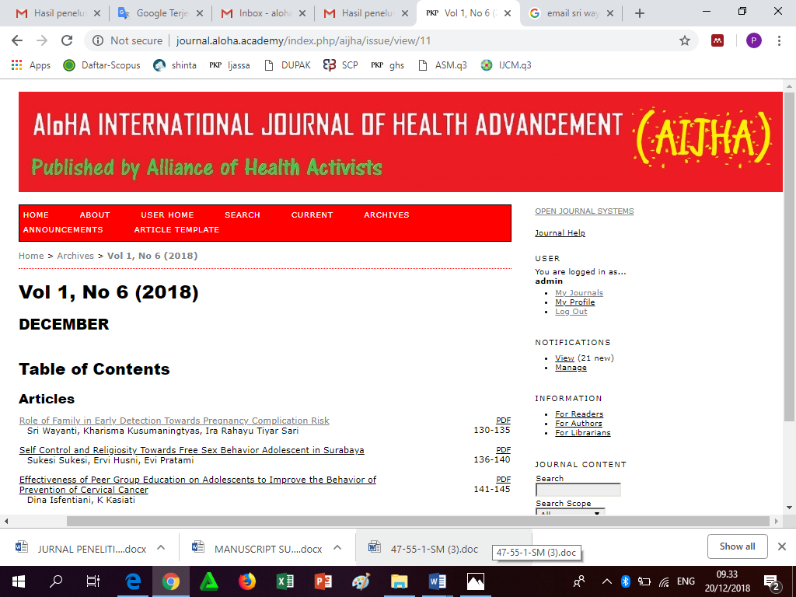

Figure 1. The Homepage Website of AIJHA

DISCUSSION

In this study, the majority of women who experience hypertension is caused by the reduced estrogen and progesterone hormones. These hormones can protect blood vessels from oxidative reactions due to pollution, food, etc., and prevent vessels from inflammation. In addition, the estrogen hormone also affects the balance of the renin angiotensin system in the kidneys which functions to maintain blood pressure stability. However, over the time, women will experience various conditions such as pregnancy, contraceptive use (especially hormonal contraception), and menopause. These conditions can cause those two hormones that previously acted as protectors to experience a drastic decrease in the amount. Therefore, entering the age of 55 years, women become equally vulnerable, even more susceptible to hypertension than men. However, it does not mean that every woman will experience hypertension when she is 55 years or older. This is because the risk of the disease can be minimized by applying a healthy lifestyle as early as possible.
From table 2. it is known that blood pressure before given ergonomic exercise shows the percentage of respondents who experienced pre-hypertension about 58.3%, stage 1 hypertension about 41.7% and after being given ergonomic exercise it changed to normal about 37.5%, pre hypertension about 56.3 % and stage 1 hypertension about 6.3%. Hypertension is not only caused by one factor but also various trigger factors, namely toxins, genetics, gender, age, diet, weight, stressful lifestyles and lack of exercise. Data obtained from each respondent varied because the factors that affect blood pressure and the causes of hypertension in individuals are different⁽²⁾.
The first factor is toxin. Toxins are residual substances from disposal that should be disposed of because they are poisonous, remnants from disposal in the blood vessels will inhibit the smooth circulation of blood vessels. The second factor is genetic. Someone who has a family with a history of hypertension, then the offspring have a greater risk of developing hypertension than families without a history of hypertension. The third factor is gender and age. Men who have entered the age of 35-50 years and post menopausal women have a higher risk of suffering from hypertension. The fourth factor is diet, someone who consumes salty foods and high fat content is directly related to the development of hypertension. The fifth factor is weight, body weight that exceeds the ideal body weight or exceeds 25% ideal body weight can also experience hypertension. The sixth factor is lifestyle, a lifestyle that is lacking or unhealthy such as smoking and consuming alcohol can also increase blood pressure and trigger hypertension. The seventh factor is stress, stress experienced by someone will arouse sympathetic nerves that will trigger the work of the heart and result in increased blood pressure. The eighth factor is lack of exercise, one tends to look for everything that is easy and practical so that the body is automatically less mobile or even unmoved. This situation triggers high cholesterol and also the presence of blood pressure that continues to strengthen, causing hypertension⁽⁷⁾.
In table 3. it is known that the pulse before being given ergonomic exercise is 25% under normal conditions and 75% is in a tachycardia condition and after being given ergonomic exercise it changed to 95.8% under normal conditions and 4.2% in tachycardia. There are several factors that affect the pulse, namely age, sex, health condition, medical history, intensity and duration of work, weight and psychological conditions, ⁽⁵⁾.
Based on the results in table 4. it is known that the stress level before ergonomic exercise is classified as very bad stress about 31.3%, bad about 25.0%, pretty good about 20.8%, good about 10.4%, very good about 12.5 %, and after ergonomic exercise, they experienced a decrease, such as those who experienced very bad stress did not exist, bad about 6.3%, good enough about 27.1%, good about 27.1%, very good about 39.6%. There are several factors that cause stress to a person, major and minor stressors⁽¹⁾.
After ergonomic exercise is given, all respondents experienced a decrease in blood pressure. Based on the theory that there are various factors that affect blood pressure, pulse and stress levels as described above, and steps to reduce blood pressure, pulse, stress levels are pharmacology and non-pharmacology. One non-pharmacological intervention is exercising like ergonomic exercise. This ergonomic gymnastics can facilitate blood circulation, supply oxygen throughout the body and increase the production of the serotonin and erdorfin or happy hormones and achieve maximum relaxation so that it can affect blood pressure, pulse and stress levels.
This ergonomic exercise is almost similar to prayer movements. In the prayer there is one opening movement while in ergonomic gymnastics there are five fundamental movements namely the opening movement (perfect standing), the first movement (chest), the second movement (submission of gratitude), the third movement (mighty sitting), the fourth movement (burning sitting) , and the last or fifth movement (lying down). Every movement contains tremendous benefits in maintaining fitness which can smooth blood flow because all blood vessels will experience vasodilation. Therefore, after doing ergonomic exercise correctly and routinely, each respondent will have a good and excellent immune system, therefore it can affect blood pressure, pulse, stress level. Not only the quality and quantity in doing ergonomic exercise, it is necessary to improve a healthy lifestyle to maintain blood pressure, pulse and stress levels so that they are in a good and normal state⁽³⁾.
The results of this study supported by previous research (16) on the effectiveness of ergonomic gymnastics with aerobic exercise on blood pressure in elderly hypertensive patients which showed that there were differences in influence between ergonomic and gymnastics. Ergonomic gymnastics is more effective against systole blood pressure and aerobic exercise is more effective against diastolic blood pressure in elderly hypertension. Therefore the elderly are encouraged to be more active in ergonomic and aerobic exercise so that blood pressure can be stable.

CONCLUSION

Based on the results of the study it can be concluded that ergonomic exercise can reduce blood pressure, pulse and stress levels in patients with primary hypertension in Sokobanah Subdistrict, Sampang Madura Regency. Therefore ergonomic exercise can be used as an alternative to non-pharmacological interventions to reduce high blood pressure, pulse and stress levels.

REFERENCES

- Andria, K. 2013. Relationship Between Behavioral Sports, Stress And Diet With Hypertension Levels In Elderly Seniors In IHC Sukolilo Gebang Putih subdistrict Surabaya. Jurnal Majority. 4(2): 11-20
- Hartono, B. 2011. Analysis of Risk Factors of Hypertension in the Village of Mount Sarik District of Kuranji. Jurnal Wiyata. 2(3): 12-23
- Psychology Foundation of Australia. 2010. Depression anxiety stress scale. Availablefrom: http://www.psy.unsw.edu.au/groups/dass [accessed on 8 october 2018].
- Sagiran. 2013. Miracles of the Prayer Movement. Jakarta.
- Silverthorn, D. 2010. Human Physiology. Jakarta: EGC
- Sherwood, L. 2014. Human Physiology : dari Sel ke Sistem. Jakarta: EGC.
- Soenarta, A. 2015. Guidelines for the Management of Hypertension in Cardiovascular Disease. Jakarta: Indonesia Heart Association.
- Susilo & Wulandari. 2011. The right way to overcome hypertension.Yogyakarta: CV Andi Offset
- American Institute of Stress. 2010. Stress, Definition of Stressor, and What is
Stress?.USA: American Institute of Stress. Available from:
http:www.stress.org/topic-definition-stress.htm. [accessed on 27
Juni, 2018].
- Andrade, C. 2015. Hypertension. health journal. 17(2): 135-142
- Azah, N. dan A, Aziz. 2011. The Method of Dealing With Stress with Prayer. Journal of Islamic and Arabic Education. 3(2): 10-16
- Chobanian, A. 2003. The JNC 7 Hypertension Guidelines--Reply. JAMA: The Journal of the American Medical Association, 4(3): 360-370
- Kholidah, E dan A, Alsa. 2012. Positive Thinking for Reducing Psychological Stress. Jurnal Psikologi. 39(1): 24-30
- Laxmeshwar, B.dan K, Amarnatha. 2015. Exercise And Stress: Get Moving To Manage Stress. Indian Journal of Applied Research X. 511(12):2249–555.
- Sandi, I. 2016. Influence of Physical Exercise Of Frequency Pulse. Sport and Fitness Journal. 4(2): 434-440

